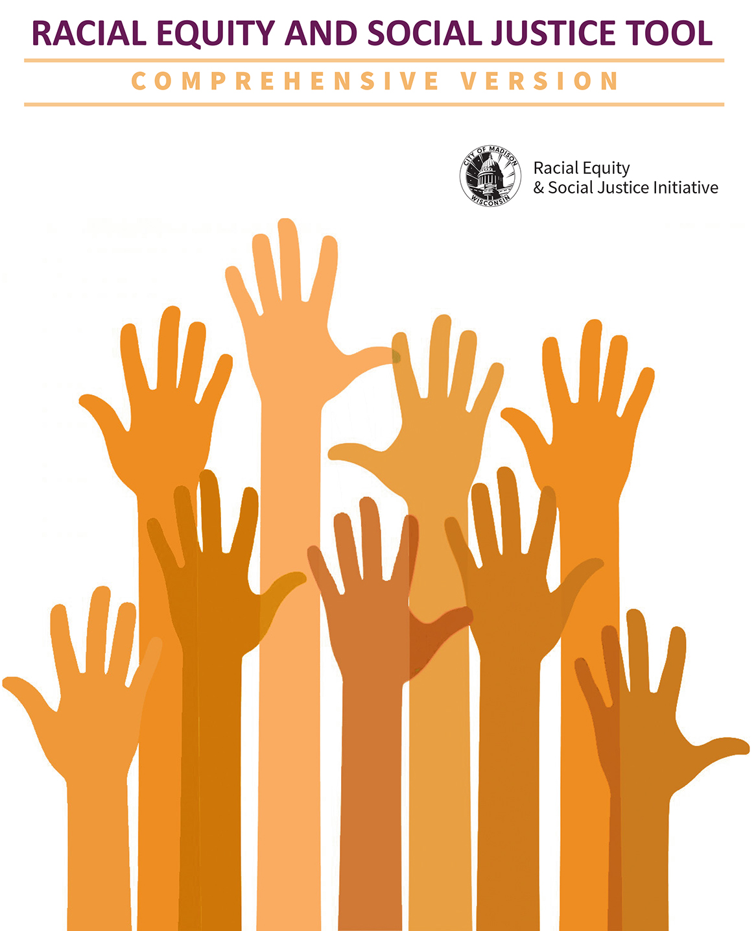

Racial Equity and Social Justice Initiative
Racial Equity Analysis Tool
Comprehensive Version

Instructions

Use this tool as early as possible in the development of City policies, plans, programs and budgets.

For issues on a short timeline or with a narrow impact, you may use the RESJI Racial Equity Analysis Tool – Fast Track Version.

This analysis should be completed by people with different racial and socioeconomic perspectives. When possible, involve those directly impacted by the issue. Include and document multiple voices in this process.

The order of questions may be re-arranged to suit your situation.

Mission of the Racial Equity and Social Justice Initiative (RESJI): To establish racial equity and social justice as core principles in all decisions, policies and functions of the City of Madison.

Equity is just and fair inclusion into a society in which all, including all racial and ethnic groups, can participate, prosper, and reach their full potential. Equity gives all people a just and fair shot in life despite historic patterns of racial and economic exclusion (www.policylink.org).

Purpose of this Tool: To facilitate conscious consideration of equity and examine how communities of color and low-income populations will be affected by a proposed action/decision of the City.

The “What, Who, Why, and How” questions of this tool are designed to lead to strategies to prevent or mitigate adverse impacts and unintended consequences on marginalized populations.

Begin Analysis

Name of topic or issue being analyzed:

Main contact name(s) and contact information for this analysis:

Names and affiliations of others participating in the analysis:

1. WHAT
a. What is the policy, plan or proposal being analyzed, and what does it seek to accomplish?

b. What factors (including existing policies and structures) associated with this issue might be affecting communities of color and/or low-income populations differently?

c. What do available data tell you about this issue? (See page 5 for guidance on data resources.)

d. What data are unavailable or missing?

e. Which focus area(s) will the policy, plan or proposal primarily impact?
Please add any comments regarding the specific impacts on each area:
 | Community/Civic Engagement  Criminal Justice  Early Childhood  Economic Development  Education  Employment  Environment | Food Access & Affordability  Government Practices  Health  Housing  Planning & Development  Service Equity  Transportation
 | Other (please describe)
 | Comments:

2. WHO
a. Who (individuals or groups) could be impacted by the issues related to this policy, plan or proposal?

b. Who would benefit?

c. Who would be burdened?

d. Are there potential disproportionate impacts on communities of color or low-income communities?

e. Have stakeholders from different racial/ethnic and socioeconomic groups⎯especially those most affected⎯been informed, involved and represented in the development of this proposal or plan? Who is missing and how can they be engaged? (See page 6 for guidance on community engagement.)

f. What input have you received from those who would be impacted and how did you gather this information? Specify sources of comments and other input.

3. WHY
a. What are the root causes or factors creating any racial or social inequities associated with this issue? (Examples: Bias in process; Lack of access or barriers; Lack of inclusive engagement)

b. What are potential unintended consequences? What benefits or burdens may result?
(Specifically consider social, economic, health and environmental impacts.)

c. What identified community needs are being met or ignored in this issue or decision?

4. WHERE
a. Are there impacts on geographic areas? (Select all that apply.)
 | All Madison neighborhoods  Allied Drive  Balsam/Russet  Brentwood/Northport Corridor  Darbo/Worthington  Hammersley/Theresa  Leopold/Arbor Hills  Owl Creek | Park Edge/Park Ridge  Southside  East Madison (general)  North Madison (general)  West Madison (general)  Downtown/Campus  Dane County (outside Madison)  Outside Dane County
 | Comments:

5. HOW: RECOMMENDATIONS SECTION
a. Describe recommended strategies to address adverse impacts, prevent unintended negative consequences and advance racial equity (program, policy, partnership and/or budget/fiscal strategies):

b. Is the proposal or plan:
Realistic?
Adequately funded?
Adequately resourced with personnel?
Adequately resourced with mechanisms (policy, systems) to ensure successful implementation and enforcement?
Adequately resourced with provisions to ensure ongoing data collection, public reporting, stakeholder participation and public accountability?
If you answered “no” to any of the above, what resources or actions are needed?

c. Who is accountable for this decision?

d. How will impacts be documented and evaluated? What are the success indicators and progress benchmarks?

e. How will those impacted by this issue be informed of progress and impacts over time?

Data Resources for Racial Equity and Social Justice Impact Analysis

City of Madison
- Neighborhood Indicators (UW Applied Population Lab and City of Madison):
http://madison.apl.wisc.edu
- Open Data Portal (City of Madison):
www.cityofmadison.com/data
- Madison Measures (City of Madison):
https://www.cityofmadison.com/finance/documents/MadisonMeasures-2016.pdf
- Census reporter (US Census Bureau):
http://censusreporter.org/profiles/06000US5502548000-madison-city-dane-county-wi

Dane County
- Geography of Opportunity: A Fair Housing Equity Assessment for Wisconsin’s Capital Region (Capital Area Regional Planning Commission):
www.capitalarearpc.org
- Race to Equity report (Wisconsin Council on Children and Families):
http://racetoequity.net
- Healthy Dane (Public Health Madison & Dane County and area healthcare organizations): www.healthydane.org
- Dane Demographics Brief (UW Applied Population Lab and UW-Extension): www.apl.wisc.edu/publications/Dane_County_Demographics_Brief_2014.pdf

State of Wisconsin
- Wisconsin Quickfacts (US Census):
U.S. Census Bureau QuickFacts: United States
- Demographics Services Center (WI Dept of Administration):
DOA Demographic Services Center (wi.gov)
- Applied Population Laboratory (UW-Madison):
www.apl.wisc.edu/data.php

Federal
- US Census:
Explore Census Data
- 2010 Census Gateway (US Census):
www.census.gov/2010census

City of Madison Racial Equity and Social Justice Community Engagement Continuum

Adapted from Community Engagement Guide: A tool to advance Equity & Social Justice in King County

The continuum provides details, characteristics and strategies for five levels of community engagement. The continuum shows a range of actions from county-led information sharing that tends to be shorter-term to longer-term community-led activities. The continuum can be used for both simple and complex efforts. As a project develops, the level of community engagement may need to change to meet changing needs and objectives.

The level of engagement will depend on various factors, including program goals, time constraints, level of program and community readiness, and capacity and resources. There is no one right level of engagement, but considering the range of engagement and its implications on your work is a key step in promoting community participation and building community trust. Regardless of the level of engagement, the role of both the City of Madison and community partners as part of the engagement process should always be clearly defined.

Levels of Engagement
City Informs  City of Madison initiates an effort, coordinates with departments and uses a variety of channels to inform community to take action | City Consults  City of Madison gathers information from the community to inform city-led projects | City engages in dialogue  City of Madison engages community members to shape city priorities and plans | City and community work together  Community and City of Madison share in decision-making to co-create solutions together | Community directs action  Community initiates and directs strategy and action with participation and technical assistance from the City of Madison
Characteristics of Engagement
- Primarily one-way channel of communication  - One interaction  - Term-limited to event  - Addresses immediate need of City and community | - Primarily one-way channel of communication  - One to multiple interactions  - Short to medium-term  - Shapes and informs city projects | - Two-way channel of communication  - Multiple interactions  - Medium to long-term  - Advancement of solutions to complex problems | - Two-way channel of communication  - Multiple interactions  - Medium to long-term  - Advancement of solutions to complex problems | - Two-way channel of communication  - Multiple interactions  - Medium to long-term  - Advancement of solutions to complex problems
Strategies
Media releases, brochures, pamphlets, outreach to vulnerable populations, ethnic media contacts, translated information, staff outreach to residents, new and social media | Focus groups, interviews, community surveys | Forums, advisory boards, stakeholder involvement, coalitions, policy development and advocacy, including legislative briefings and testimony, workshops, community-wide events | Co-led community meetings, advisory boards, coalitions and partnerships, policy development and advocacy, including legislative briefings and testimony | Community-led planning efforts, community-hosted forums, collaborative partnerships, coalitions, policy development and advocacy, including legislative briefings and testimony

NOTES

